John Hunter Children’s Hospital Weight Management Service Referral Form
Please fax completed form to the Referral Information Management System 02 4922 3904
Patient details:
Given Name: |  | Surname:
DOB: | □ Male □ Female | □ Aboriginal □ Torres Strait Islander

Parent/Carer Contact Details:
Name: | Relationship to Child:
Contact Ph: | Alternative contact number:
Is an interpreter required? □ Yes □ No If Yes, specify language:
Is assistance required to complete forms □ Yes □ No

Clinical details:
Weight: kg |  | Height: cm
BMI: kg/m²
□ High BP  (>95% - see link below) | □ Symptoms of obstructive sleep apnoea | □ Joint pain or other musculoskeletal complications e.g. SCFE | □ Acanthosis nigricans
□ Psychosocial consequences  Specify: |  | □ Behavioural problems  Specify:
Other significant medical/social history:
Please attach copies of the following investigations (essential for 7-17 years):
□ Fasting BGL | □ FBC | □ EUC | □ LFT
□ Fasting lipid profile  (Chol/LDL/HDL/TG) | □ HbA1c | □ Vit D | □ TSH
Please attach copies of the following investigations if available:
□ OGTT | □ Sleep study | □ Other:
Has the child/family had previous engagement with a weight management service e.g Go4Fun or dietitian
□ Yes □ No
Please specify:
Patient Agreement
I, …………………………………............................(parent/guardian signature) have discussed the referral to John Hunter Children’s Hospital Weight Management Service with our doctor and consent to participate. I understand that participation in the clinic requires regular attendance and monitoring of progress and that measurements and progress will be recorded and used for ongoing evaluation of the program.
Referring Doctor Details
Name: | Provider Number:
Address: | Phone:
Signature: | Date:

BMI centile charts taken from CDC Growth charts.
BMI = weight in kg ÷ (Height in metres)2

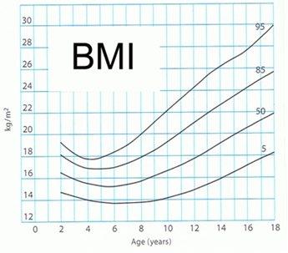
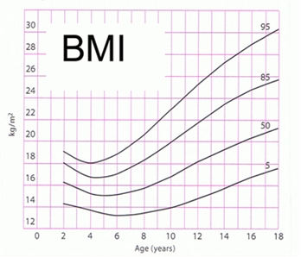
Blood pressure percentile information available at:
http://www.rch.org.au/clinicalguide/guideline_index/hypertension/

