Go4Fun® Online
Go4Fun® Online is a free, ten week healthy lifestyle program for children in NSW aged 7 to 13 years who are above a healthy weight, and their families. Children are eligible to participate in the program if they:
- Are aged 7 -13 years
- Have a body mass index ≥85th percentile for their age and gender
- Live in New South Wales
Go4Fun® Online has been developed to provide access to families who are unable to join a face-to-face Go4Fun® program. Examples of families who may benefit from the program include:
- Families living in rural and regional areas
- Families in areas where face-to-face programs are not delivered
- Families who find group environments challenging
- Families experiencing personal circumstances that limit them from attending a face-to-face program
- Families with work commitments that limit them from attending a face-to-face program
- Families with children who have additional needs that are not suited to the face-to-face program
Go4Fun® Online can be undertaken in the comfort of the family’s home with flexibility around the timing of when the family completes the different elements. Parents/carers actively participate in the program to encourage the whole family to get involved. Families complete the program over 10 weeks in line with the school term.
The program is designed to encourage positive behaviour change in families and is made up of:
10 weekly online learning modules
10 weekly phone calls from a health coach to support families during the program
Weekly physical activity and nutrition targets and activity tracker
A closed Facebook community group for families to share their experiences and support with other families
Hardcopy resources (welcome pack, physical activity equipment, recipe book, activity sheets, handouts)
SMS and email reminders
Incentive and reward system with prizes
A copy of the child’s results will be provided following their participation in the program.

For more information
please visit www.go4funonline.com.au
or call 1800 780 900

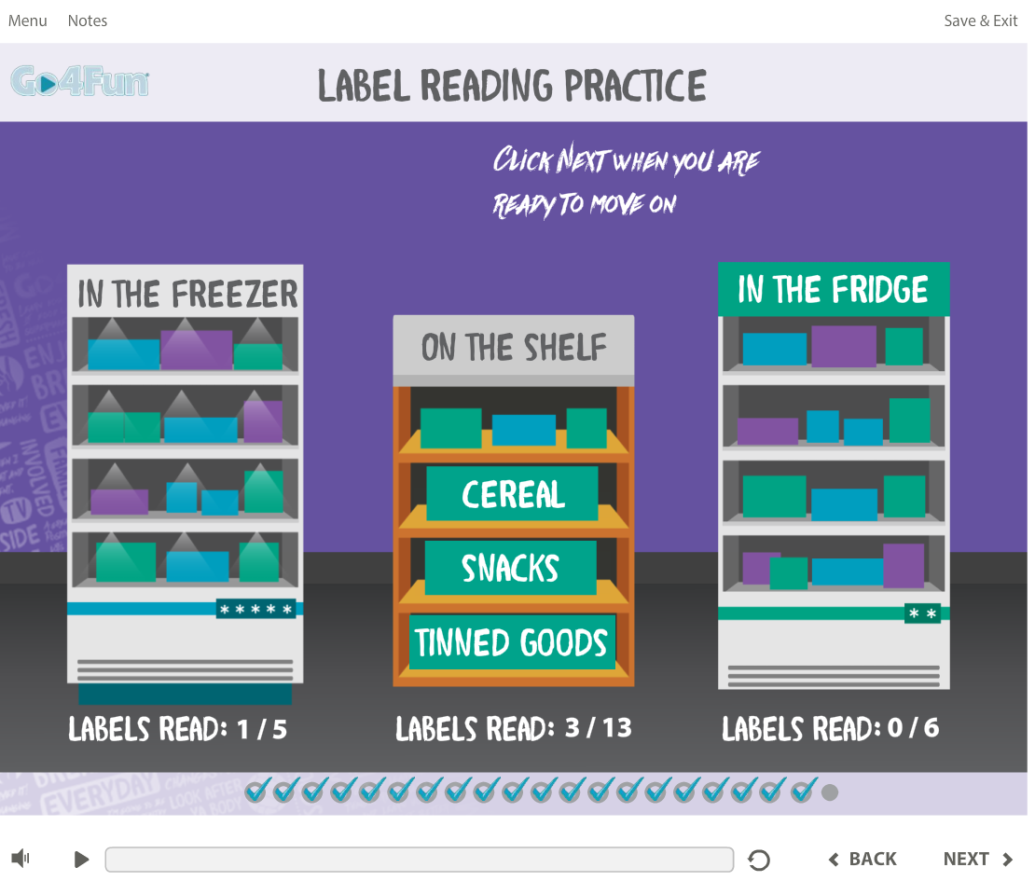

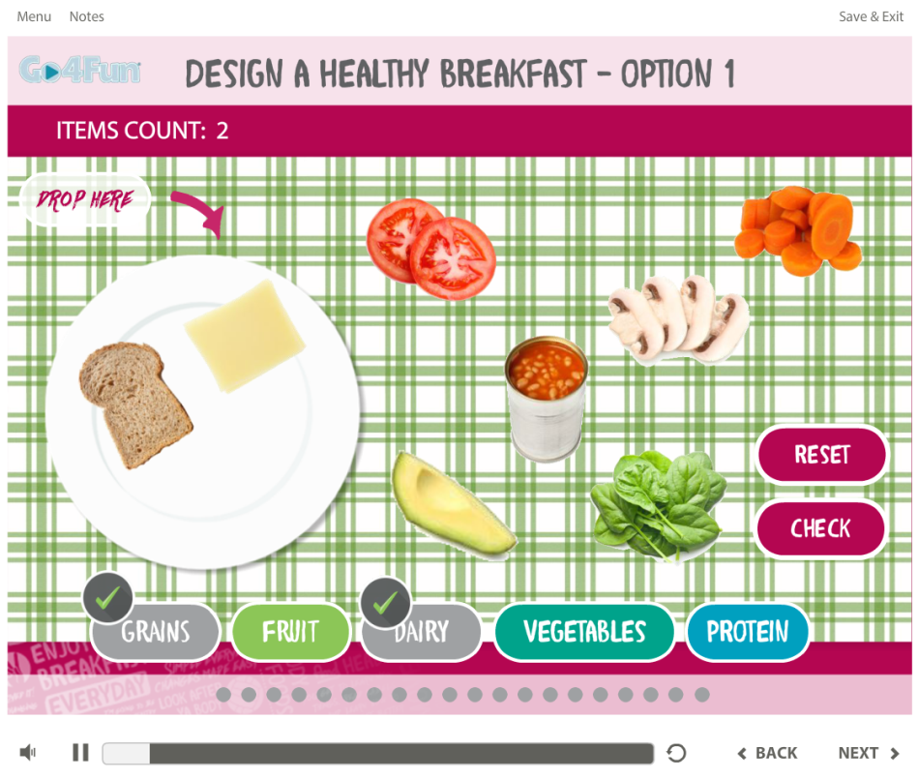

Did you know?

- Go4Fun® referral forms are available via Medical Director and Best Practice software. Go4Fun will take care of the rest with your patient.
- Hard copies of the referral form can be ordered by phoning the Go4Fun® team on 1800 780 900.
- The Healthy Kids Pro website provides a suite of resources to assist health professionals to manage children above a healthy weight (https://pro.healthykids.nsw.gov.au/)
- A weight status calculator is available on Healthy Kids Pro to identify if a child is a healthy weight for their height and age https://pro.healthykids.nsw.gov.au/calculator/
- Go4Fun® is delivering a series of accredited RACGP webinars titled “Healthy Kids for Professionals.”

