Healthy Families
The Charles
Perkins Centre

Charles Perkins Centre RPA Clinic
Level 1, The Hub, Charles Perkins Centre, John Hopkins Drive
University of Sydney NSW 2006

Belmore Early Childcare Health Centre
38 Redman Parade, Belmore
Ph: 8627 0403, Fax: 8627 0141

Health Professional Referral Form - Fax completed form to 8627 0141
A dietetic weight management service for overweight or obese children (above the 85th centile) aged 6-16 years old and their families staffed by:
Dietitian – Neha Prasad

PATIENT DETAILS
Surname: | First name:
Date of birth: | Sex: Male Female Other

PARENT / CARER CONTACT DETAILS
Name:
Home phone: | Mobile phone:
Home address:
Language spoken at home:
Interpreter required: Yes No | If yes, specify language:

CLINICAL DETAILS
Weight: |  | Height:
BMI: | BMI centile:
(see reverse of this page for calculation and tables)
Go4Fun completion date if applicable:
Investigations if already performed; please attach any relevant pathology details
Not needed routinely, please attach results if applicable.
(Consider fasting BSL, insulin, TG, cholesterol +/- vit D, iron studies, LFTs.)
Other significant medical or social history:

PATIENT AGREEMENT

I, …………………….…………………………. (parent / guardian name) have discussed the referral to the Family-focused Healthy Lifestyle Service with our health professional and consent to participate. I understand that participation in the clinic requires regular attendance and monitoring of progress and that measurements and progress will be recorded and used for ongoing evaluation of the clinic program.

…………………….…………………………. (parent / guardian signature)
REFERRING DOCTOR/ HEALTH PROFESSIONAL DETAILS

Name:
Clinical role:
Provider number: (if applicable) Email:
Address:
Phone: | Fax:
Signature: | Date:
Paediatrician / GP details: (if applicable)

BMI centile charts taken from CDC Growth charts Overweight is defined as 85th to 95th centile for age. Obese is defined as over the 95th centile for age.
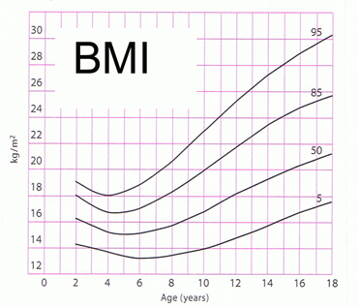
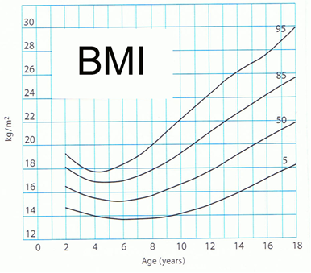
Girls
Boys

Body mass index (BMI) = weight (kilograms) ÷ height (metres)²

